

**Faculty:** IT

**Course Name:** Computer Maintenance

**Course Code:**  INSY 8121

**Lecturer:** Joshua IRADUKUNDA

**Student Name:** MUTANGANA Joseph

**Student ID:** 29061

**Report:** Assignment#0

**Table of content**

Task 1: Professional Profile: 1

Task 2: Goals for the Course and Career 1

Task 3: Installation of Required Software 2

Canvas Profil 2

Task 4: Completion of “Computer Hardware Basics” 3

Module 1: Personal Computers 3

Module 2: Laptops 3

Module 3: Other Mobile Devices 3

Badge: Computer Hardware Basics 3

www.linkedin.com/in/mutangana-joseph 4

Task 5: Agreement and Commitment Plan 4

Class Conduct 4

Avoiding Distractions 4

Plagiarism, Similarity, and Cheating 4

Concsequenses for violation 4

#### Task 1: Professional Profile:

[www.linkedin.com/in/mutangana-joseph](http://www.linkedin.com/in/mutangana-joseph)

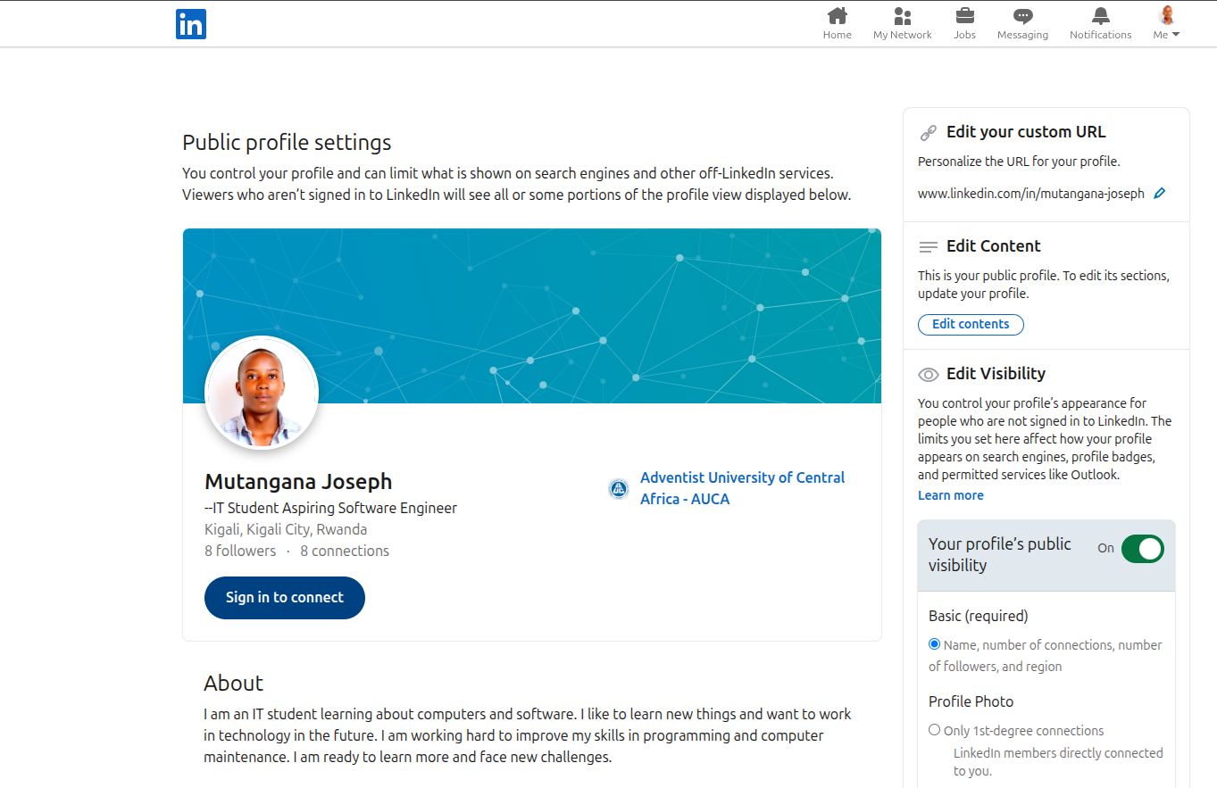

#### Task 2: Goals for the Course and Career

**Course Goals:**

1. By the end of this course, I aim to be able to work well with my computer, solve technical problem that may affect my it, and also help others with skills I gained in this course.
2. I want to fell confident in solving technical issues related to computer maintenance.

**Career Goals:**

1. As an enthusiastic IT student aspiring to become software engineer, my goal is to understand important tools in this field, earn a strong degree, and be ready to work in the tech industry with creative skills.
2. Getting a good job related to IT, This will be my reward for working hard, and it will allow me to contribute to the digital world.
3. I’m aiming to work as web designer as of my job roles.
4. Also aiming to get CISCO certificate to increase my knowledge and qualifications.

**Process and Strategies:**

1. I am using my time to train myself and understand what the IT career requires. I also research experienced professionals in the field to learn how they reached their goals. Working with classmates and others helps me build strong connections.
2. I plan to earn a Bachelor’s degree at Adventist University of Central Africa (AUCA), then continue to a Master’s degree, and later work toward a Doctor of Philosophy (PhD).
3. Continuous learning and staying updated with the latest technology trends is important. It helps me understand what is needed at each stage and stay connected with how technology is changing.

**Importance and impact:**

1. These goals will help me live a meaningful life, apply my skills, and explore opportunities in the tech world. They will also help me support myself and my future family.
2. Personally and professionally, achieving these goals will increase my value in the tech industry. It will also help me build a strong professional profile, for example on Linked-in, and gain real experience.
3. Achieving these goals will make me more confident to apply my skills and express myself. It will feel like a dream come true and bring real career satisfaction.

**Excitement and Opportunities:**

1. I’m very excited to achieve this goals because it will open doors of my career and I’m motivated because it cant work it self I must put effort in each process to achieve this goals.
2. I expect to feel proud and confident when I achieve these milestones because they show the progress I'm making in my career. It will motivate me to keep learning and growing in the IT field, and I’ll feel more ready to take on real-world challenges.
3. Achieving these goals will open many opportunities for me. I will be more qualified for internships and jobs in IT, which can help me start my career early. It can also lead to better positions with higher pay in the future. I’ll gain more confidence and enjoy my work because I’ll be doing something I’m skilled in and passionate about. These milestones can also connect me with professionals and open doors to more learning and growth.

#### Task 3: Installation of Required Software

Canvas Profil**e**

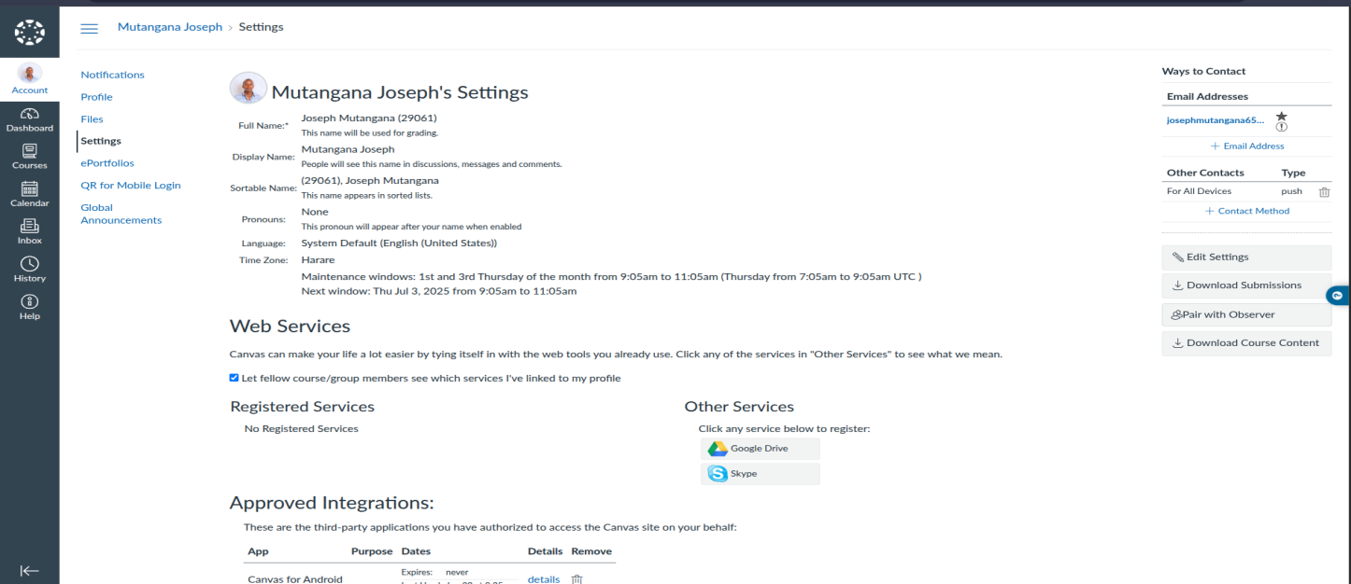

#### Task 4: Completion of “Computer Hardware Basics”

**Reflection on Computer Hardware Basics Courses Modules**

**Module-by-Module Review:**

##### Module 1: Personal Computers

In this module, I learned General and fire safety and Computer disassembly, installing motherboard and what I observed is how to disassembly

##### Module 2: Laptops

I learned Laptop Components, Laptop wireless configuration, preventing Maintenance for Laptops and I observed how to congratulate wireless.

##### Module 3: Other Mobile Devices

I learned Mobile Device Overview and other Mobile Device Hardware, and I observed In other Mobile Overview, way of wireless connection and shared internet work.

#### Badge: Computer Hardware Basics

https://www.credly.com/badges/27630245-6613-4ce7-8de0-424514c451ef/linked_in_profile

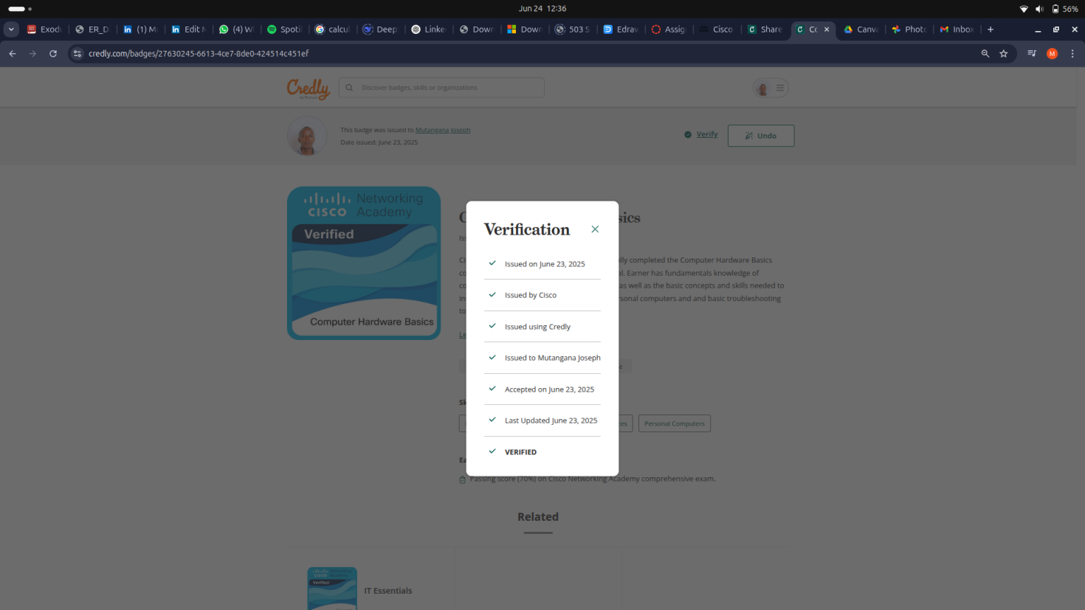

#### [www.linkedin.com/in/mutangana-joseph](http://www.linkedin.com/in/mutangana-joseph)

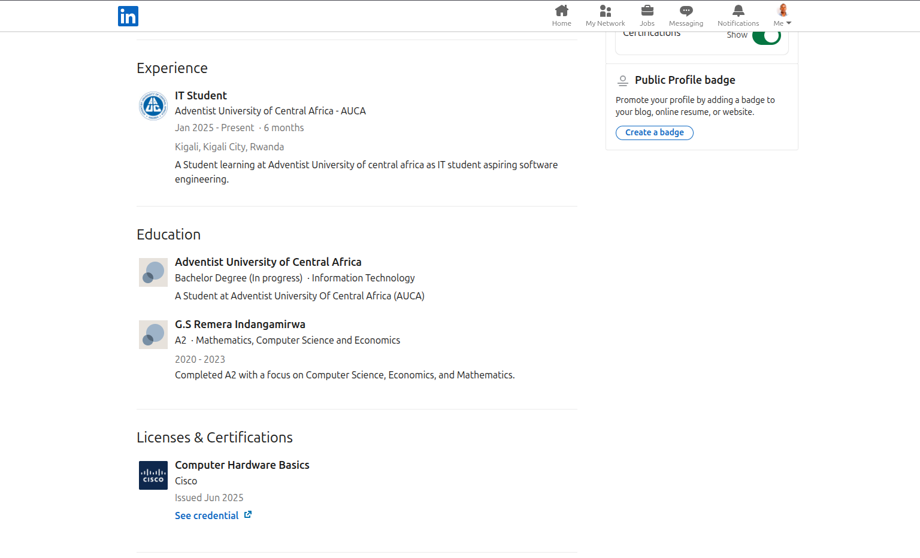

#### Task 5: Agreement and Commitment Plan

Class Conduct: I will follow the rules of the class and respect my teacher and classmates. I will participate in discussions and do my work on time

Avoiding Distractions: I will stay focused in class and avoid using my phone or doing anything that can take away my attention.

Plagiarism, Similarity, and Cheating: I understand that copying others work is not allowed. I will always do my own work and avoid cheating

Consequences for violation: If I break any rule, I accept the punishment, which can include losing marks, being suspended.